**How to launch an EC2 Instance:**

1. **Log in to AWS Management Console**:  
   Search for "EC2" in the search bar and select **EC2** from the results

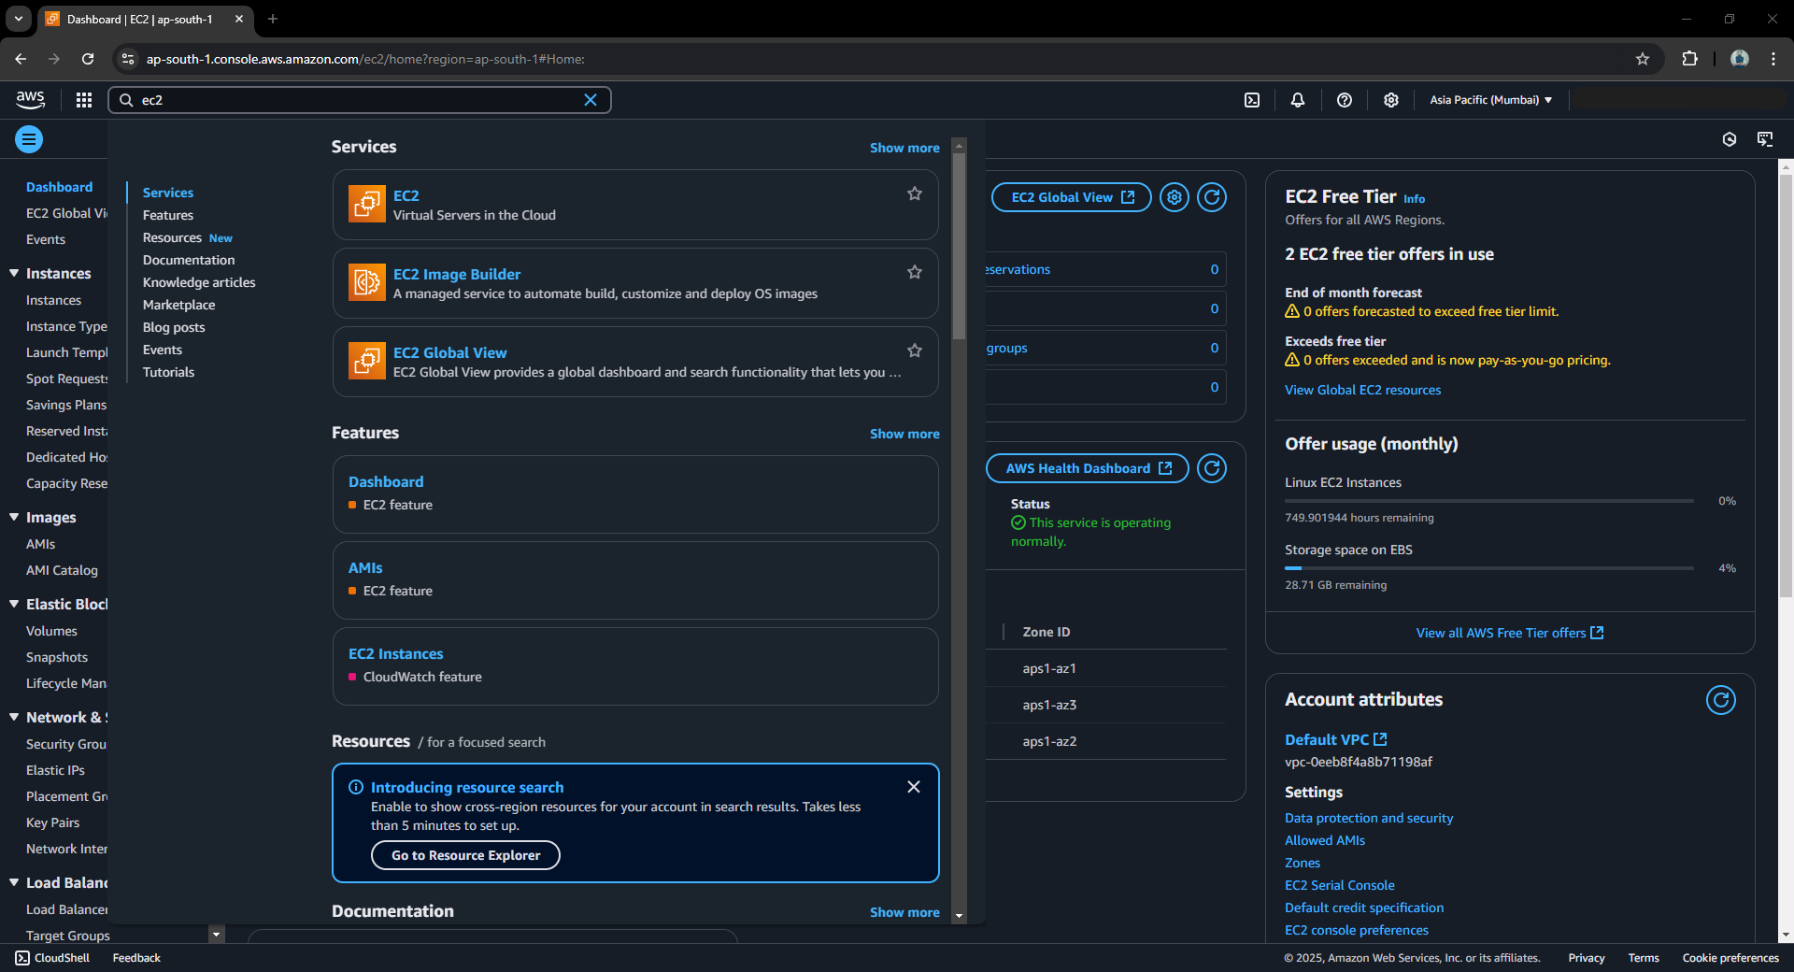

1. **Navigate to Instances**:  
   Click on **Instances** from the menu options. To launch an EC2 instance, click on **Launch Instances**.

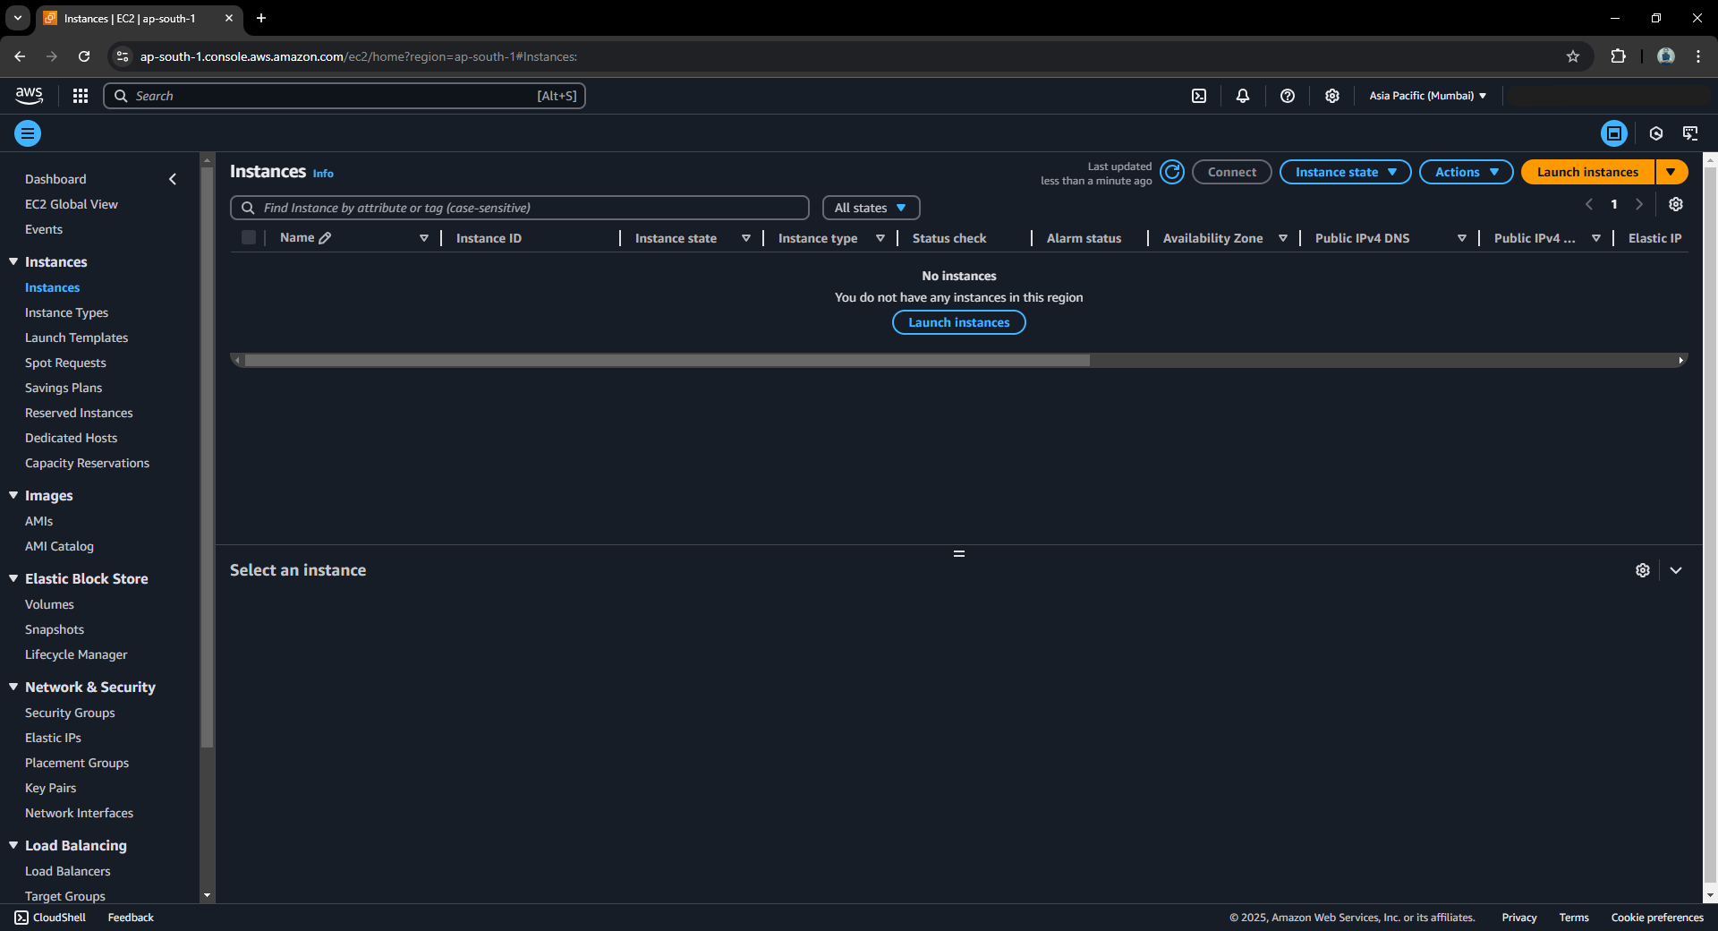

1. **Enter the Instance Name**:  
   Provide a name for your EC2 instance.

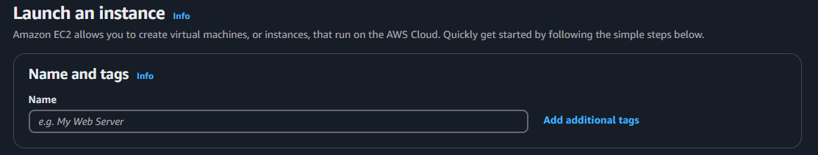

1. **Choose an AMI (Amazon Machine Image)**:  
   Select the operating system (OS) for your instance.

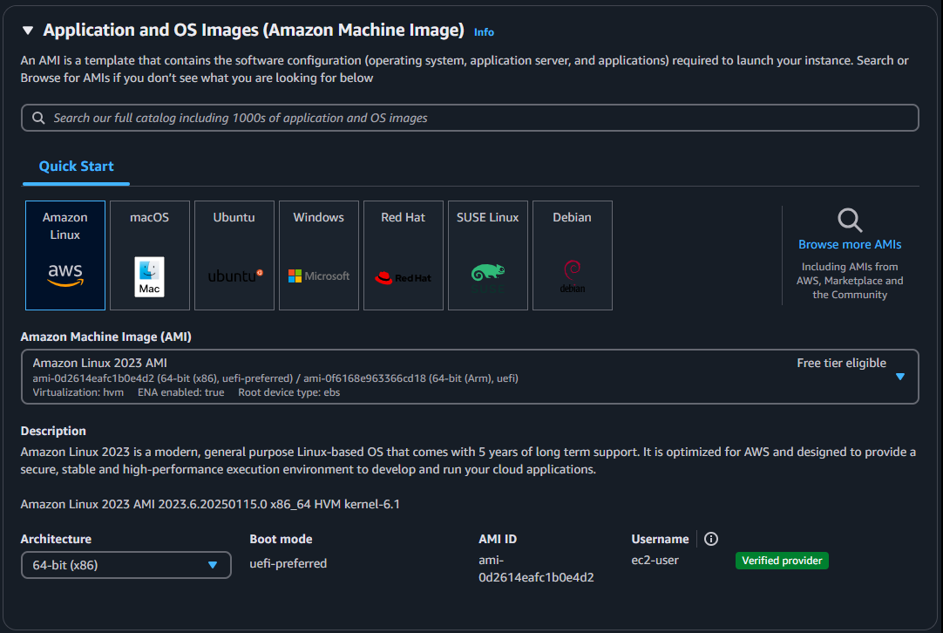

1. **Select the Instance Type**:  
   Choose an instance type based on your required number of CPUs, storage needs, and budget.

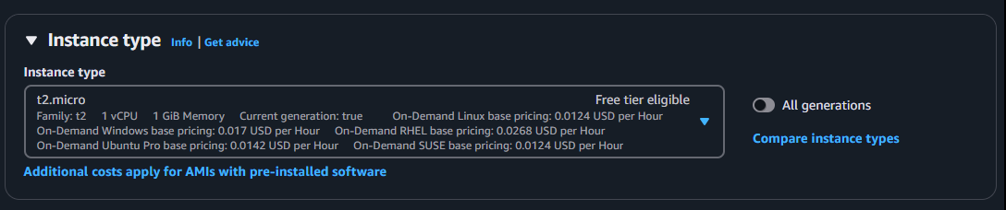

1. **Create or Select a Key Pair**:
   * A key pair consists of security credentials used to securely log in to your EC2 instance.
   * **Private Key**: Stored locally on your computer and required to connect to the instance.
   * **Public Key**: Stored in the EC2 instance during its launch. AWS uses this key to verify the private key during authentication.  
     Create a new key pair and save it to your computer, or select an existing key pair.

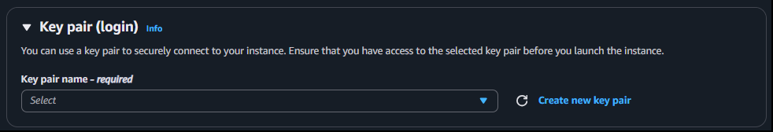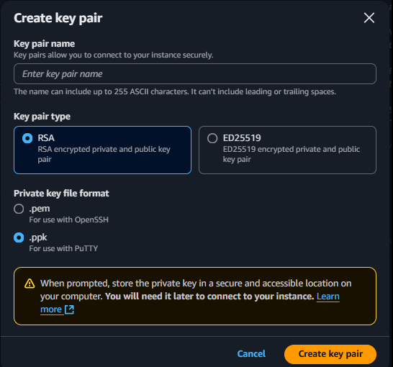

1. **Configure Network Settings**:
   * **VPC (Virtual Private Cloud)**: Choose a VPC or use the default one provided.
   * **Subnet**: Select or create a subnet.
   * **Security Group**: Choose a security group. A security group is a set of firewall rules that control the inbound and outbound traffic for your instance.

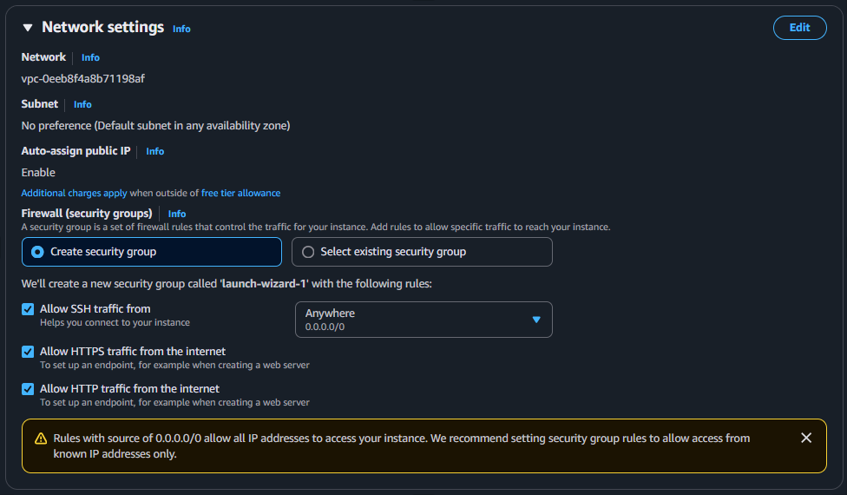

1. **Configure Storage**:  
   Set up storage using EBS (Elastic Block Store). Choose the necessary volume and storage size.

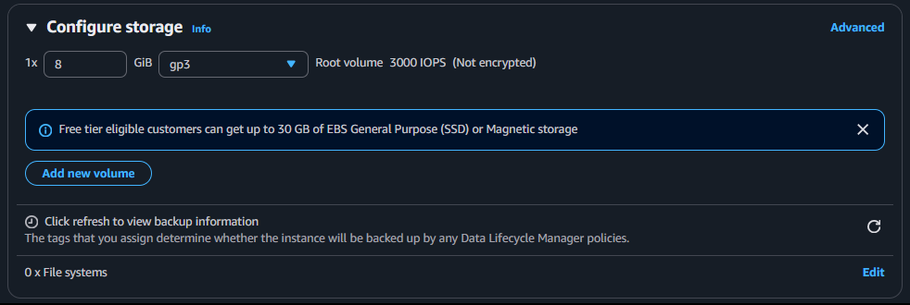

1. **Add User Data (Optional)**:  
   User data is a script that runs when the EC2 instance is first launched. It is executed as the root user.

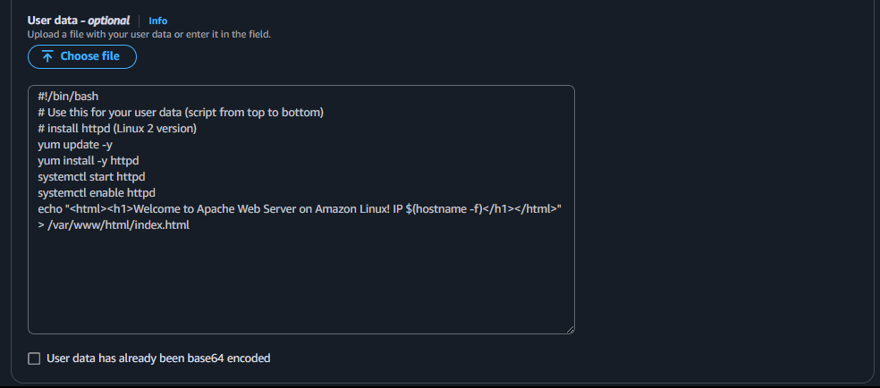

1. **Review and Launch**:  
   Verify all the configurations to ensure they meet your requirements. Once satisfied, click on **Launch Instance**.

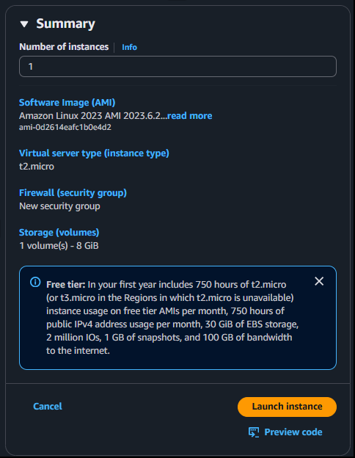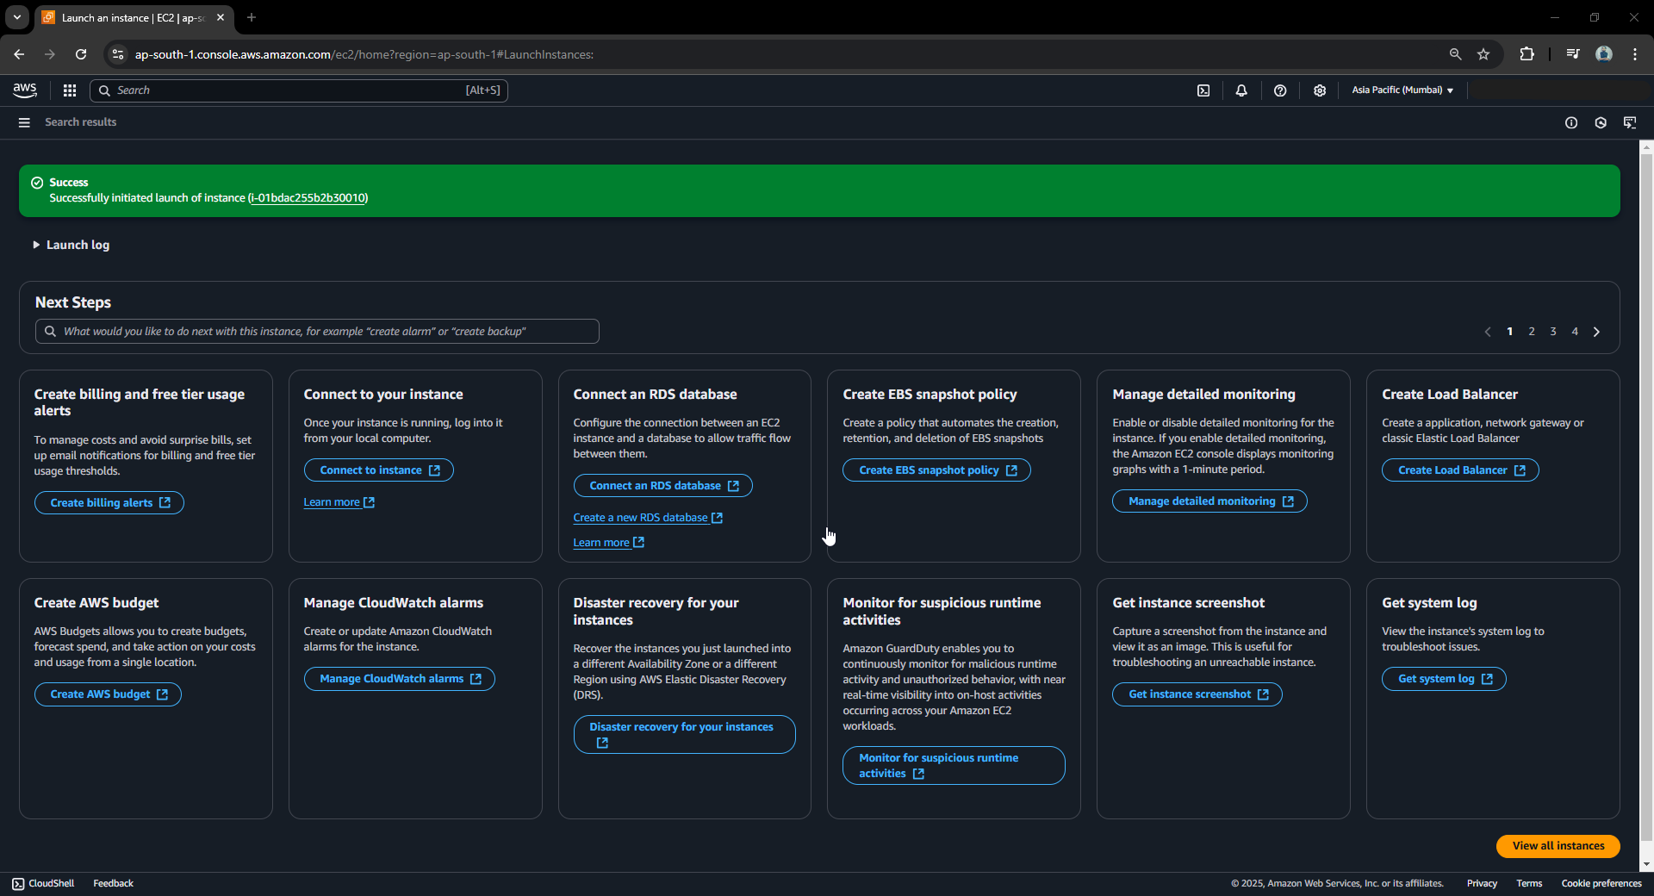

1. **Verify Instance Status**:  
   After launching, confirm that your instance is running. To check if the web server is running, open the public IP address of the instance in your browser.

